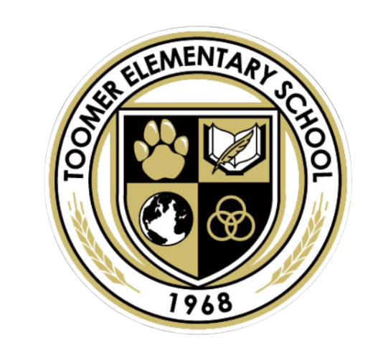

**Toomer Mission Statement**

**2021-2022**

**At Toomer, we cultivate global citizens and life-long learners through inquiry, voice, choice, and agency. We provide a safe and equitable community that embraces diversity to inspire students to become critical agents of change.**